## How to Install Remote Access Client

The Remote Access Client is an application that resides on your computer so that we can remote control your computer to fix issues that you may have. We also use it to perform preventative maintenance after hours so we can keep downtime to a minimum.

1. Open your favorite browser such as Chrome, Microsoft Edge or FireFox.
2. Navigate to [www.prophetcomputers.com](http://www.prophetcomputers.com). The website should look something like this:  
   A screenshot of a website

   Description automatically generated
3. Select the “Support” menu item next to About
4. Next you will select Remote Access download. The Remote Access download is the small application that allows us to access your computer without you being present and allows us to perform maintenance and/or preventative maintenance after hours or while you are away.  
    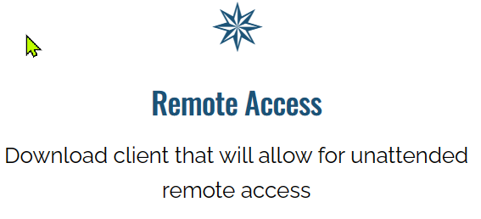
5. You will see the download page and select “Download Remote Access”  
   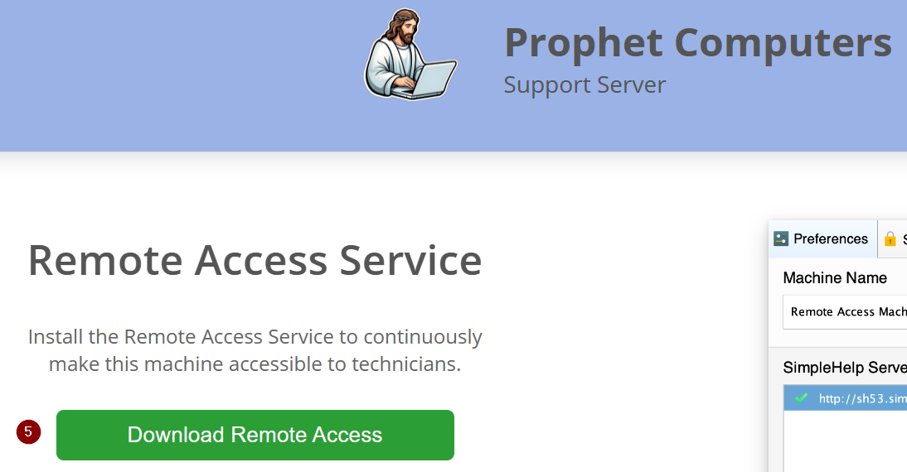
6. Next you should see the download information such as this Windows 11 notification  
   A grey rectangular sign with white text

   Description automatically generated
7. You can either click on the name to start the install, click on the folder next to it to copy or move the downloaded file, or click on the trash can to remove the download.
8. For this example, we will click on the file name in order to install the client.
9. You will now see this prompt and you will want to select “Yes”  
   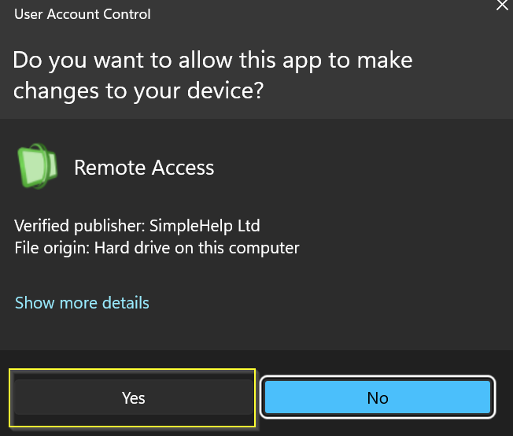.
10. You should now see the Remote Access Client begin the install
11. You will now see the Remote Access Service configuration box. This is important.  
    In the field name “Machine Name” you will want to enter a name that allows you to know who’s computer it is. In this way, if you call and say we have a problem with Sandra’s computer, if you have named it Sandra, then we can know which computer to work on.  
    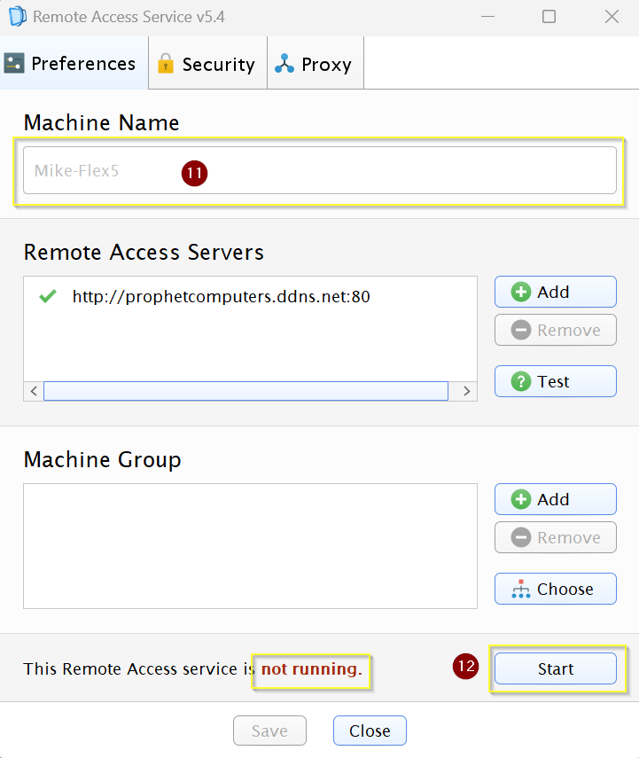
12. Next in the same illustration, you will notice at the bottom of the box is shows “This Remote Access service is not running” you will want to click on the Start button and it should change to Running. If it says running, you may click on the Close button and you are done with the install.